

CUREB CuResearch User Guide

Browser Compatibility
Internet Explorer 9, 10 or 11, Firefox 25, 26, or 27, or Google Chrome
(Safari DOES NOT provide full functionality)
CuResearch Researcher Portal

Table of Contents (control + click to navigate to a specific section)
CUREB CuResearch User Guide 1
Browser Compatibility 1
How to submit a new CUREB Ethics Application: 3
How to submit revisions to a CUREB Ethics Application: 10
Submit an Event in CuResearch (a Renewal Request, Closure Report, Change to Protocol or Adverse Events form, or Protocol form following a release of funds) in CuResearch 15
How to Re-Submit an Event in CuResearch 19
Frequently Asked Questions 24
1. What is the limit for attachments? 24
2. What does “user not validated” mean? How does a user become validated? 24
3. How do I remove the Errors tab? 24
4. Will I receive notifications in CuResearch? 24
5. I think I locked my account. How do I fix it? 24
6. I am having trouble with the forms. Do I need specific software to fill out the forms before I upload them to CuResearch? 25

How to submit a CUREB Ethics Application:
The CUREB protocol form, Very Low Risk Form, Request to Release Funds form, Course Based Research Form, and Secondary Use form are all submitted as new applications.

- First time users should request a user account for CuResearch on our website.
  - The coordinator will send a confirmation email when the new user account is created.

- Log into the CuResearch Researcher Portal with your MyCarletonOne credentials.

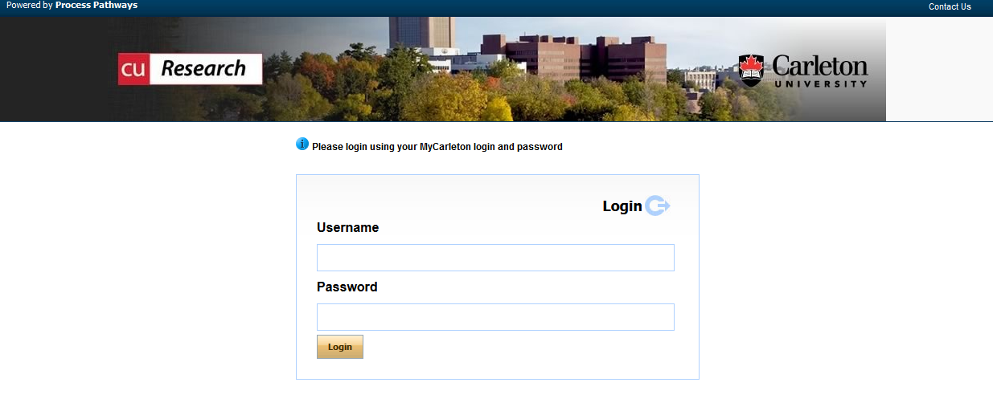

- Select Apply New on the home page to view a list of all available application forms.

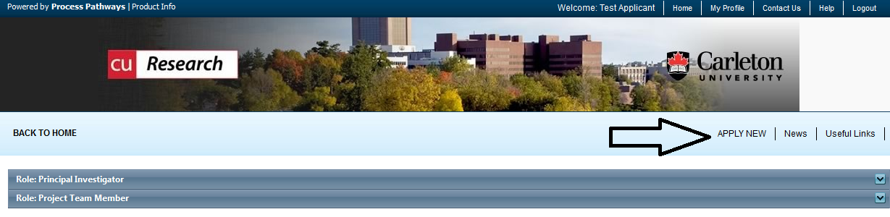

- Select the name of the application for the certification are applying for:
  - CUREB-A Applicants - select the CUREB-A Protocol Form;
  - CUREB-B applicants - select the CUREB-B Protocol Form.

Example: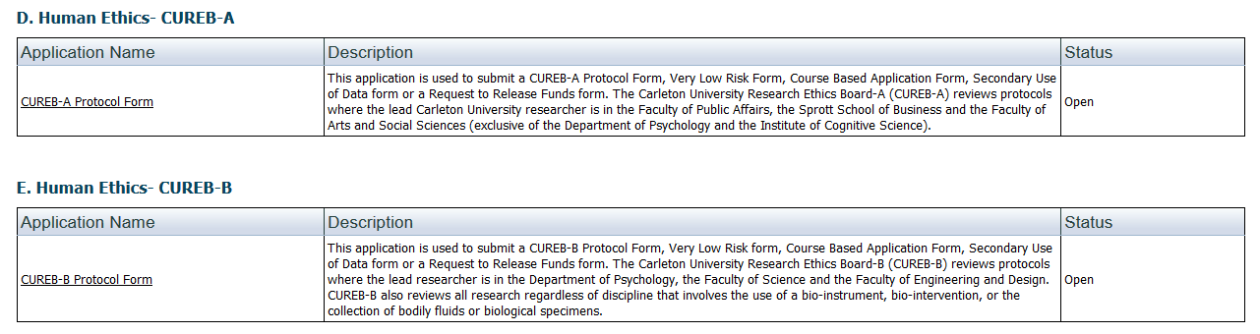

NOTES:
- Closing the file without saving first may cause the file to be locked and information entered to be lost.
  - Contact the Research Ethics Coordinator at ethics@carleton.ca to unlock the file.
- Fields marked with a red asterisk are mandatory.

- Under the Project Info tab:
  - Project title: enter the title of your project
  - Enter the Start Date and End Date of the study
  - Key Words: not required

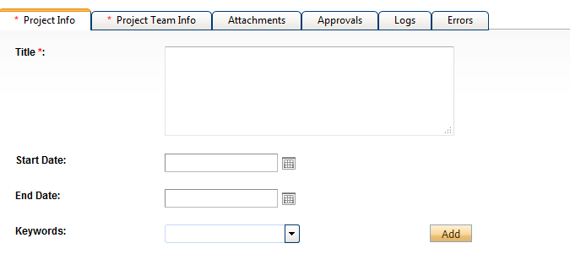

  - Related Awards - If an award is linked to the study:
    - Click on the Search key located under Related Awards,
    - You will be brought to a screen, similar to the one that follows, and all awards associated with the PI’s should appear.
    - Please note: If this is a teaching protocol, you are not required to select an award.
    - If your award is not listed, please advise the Research Ethics Coordinator for CUREB at ethics@carleton.ca.

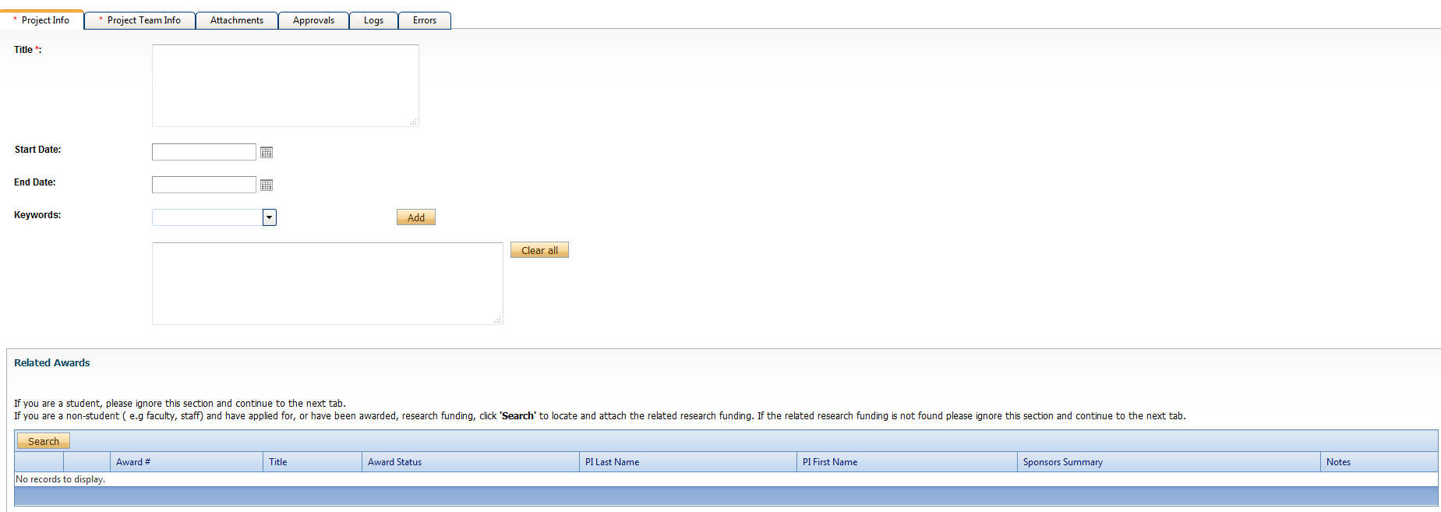
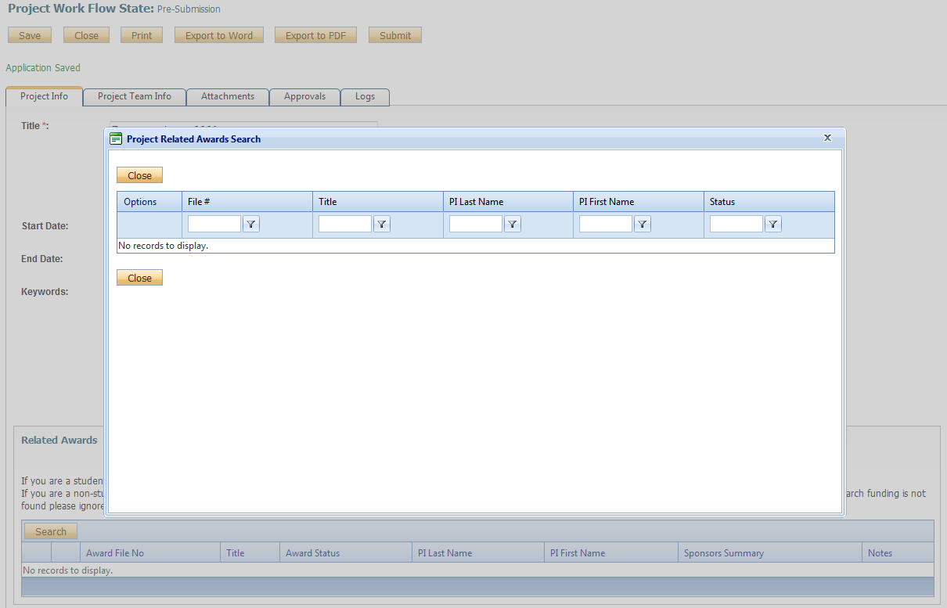
- Project Team Info tab.
  - If you are a student, ensure your supervisor is listed under Project Members, if they are not listed as the PI.
  - Search and select Other Project Members that have been given access to CuResearch by the Office of Research Ethics
  - Note: When searching you must click “Search Profiles,” instead of selecting enter.
    - Project team members must be given a role in the project (such as Supervisor, Research Assistant, Collaborator, or Co-Investigator).
    - Adjunct faculty members and external supervisors should also be listed in the Project Team Member tab.
  - If the person you want to add does not come up, do not type in the information, have them request an account on our website.

- Attachments - Attach your completed CUREB Protocol.
  - Forms and templates can be found on our website.
    - Note: the limit for attachments is 10MB per attachment. You may attach files in WORD or PDF format.
- Select Add Attachment.
- Enter a description, if applicable (e.g., Ethics Protocol, Study Appendices, TCPS2 completion certificate).
- Click Browse to add the appropriate attachment.
- Enter the version date (date of submission) using the calendar tool.
- Select the Doc/Agreement to identify a broad category of attachment (e.g., Project Form, Consent Form).
- Click Add Attachment to upload the attachment to the protocol form.

Note: Student Researchers: CUREB requires proof of review by your faculty supervisor/sponsor. You must fill out, have your supervisor sign, and submit a Supervisor Signature Form from our website’s Forms and Templates page.

- If your application is complete, click “Submit”. If you would like to return to work on the application, click “Save.”
  - If you save it, the application will be saved under Applications: Drafts in the drop-down menu on your home page.

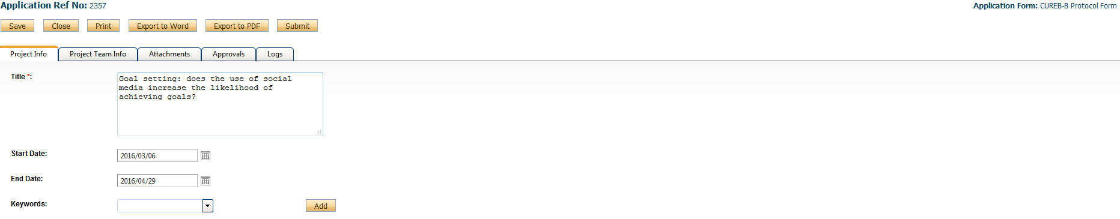

- A text-box window will pop-up after you select “Submit.” In this box, researchers can leave any pertinent notes for the Research Ethics Coordinator regarding the application. When the textbox pops up afterward, type something in the box, and then click “Submit” again – if you do not, it does not go into the system.

- An email confirmation will be sent from CuResearch when the application has been submitted.

How to submit revisions to a CUREB Ethics Application:

- The research team can expect to receive an email from the Office of Research Ethics when CUREB review comments have been released.
  - This email will contain a list of the required revisions.
  - You will prepare a point-by-point response letter where you list the comments provided and response to each one. You will include this with the revised documents (e.g., protocol form, appendices), which you will re-submit with changes highlighted in yellow.

- Log into the CuResearch Researcher Portal with your MyCarletonOne credentials.

- Click Applications: Requiring Attention in the Principal Investigator or Team Member sections of the CuResearch home page.
  - The location of the protocol will depend on your role in the study (i.e, if you are the PI it will be under “Role: Principal Investigator, if you are another team member, it will be under “Role: Project Team Member”).

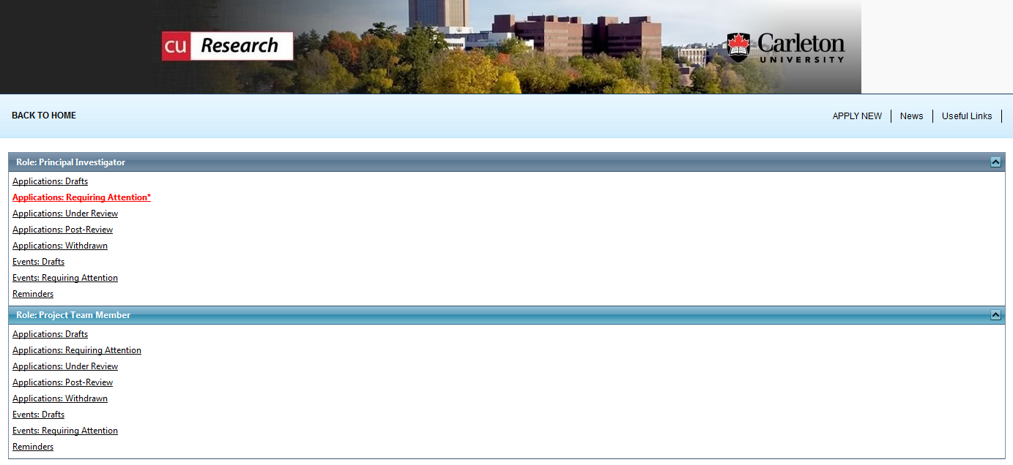

- Protocols in this list can be viewed or edited.
  - Click Edit.

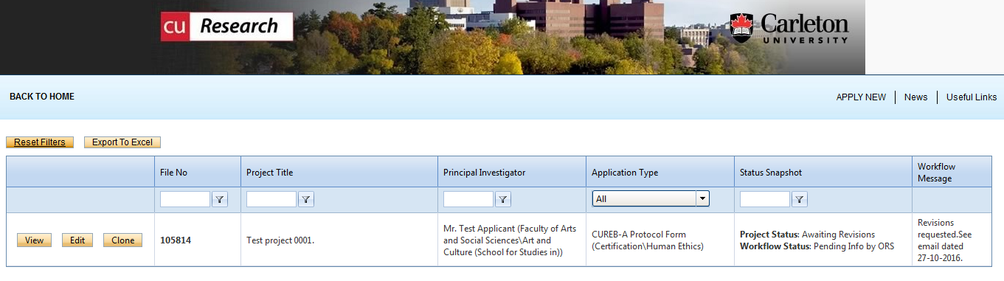

- Proceed to the Attachments tab. Attach your point-by-point response letter, revised protocol form, and appendices, as required:

Note: the limit for attachments is 10MB per attachment. You may attach files in Word or PDF format.
- Select Add Attachment to add a revised protocol. Please do not edit or delete existing attachments; CUREB will keep all previous versions of the protocol and appendices on file for record keeping purposes.
- Enter a description, if applicable (e.g., Revised Protocol, Revised Study Appendices, TCPS2 Certificate).
- Click Browse to add the appropriate attachment.
- Enter the Version Date or select the appropriate date using the calendar tool.
- Select the Doc/Agreement to identify a broad category of attachment (e.g., Application Form, Consent Form).
- Click Add Attachment to upload the attachment to the project file.

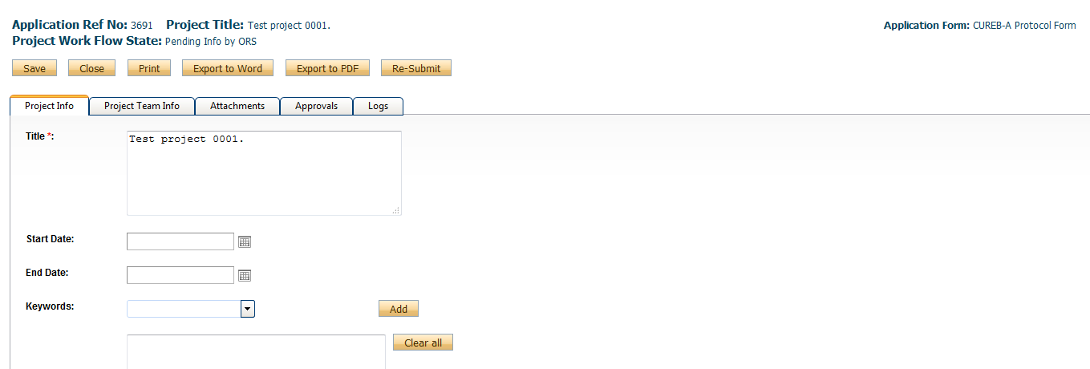

- When all of the revisions have been added, click “Re-Submit”.

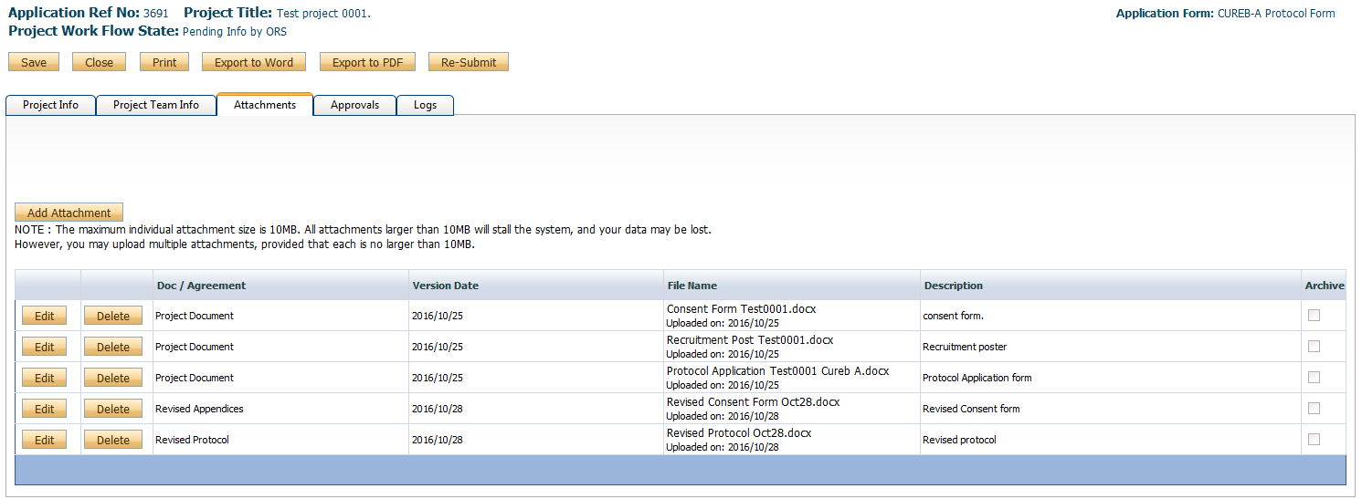

- A text-box window will pop-up after you select “Re-Submit.” In this box, researchers can leave any pertinent notes for the Research Ethics Coordinator regarding the application. When the textbox pops up afterward, type something in the box, and then click “Submit” again – if you do not, it does not go into the system.

- Your application will now move to the Applications Submitted-Under Review section of the CuResearch home page.

- An email confirmation will be sent from CuResearch when the application has been re-submitted.

- You will be able to check the status of the application in the Log Workflow Status, which tracks all data and workflow activities.
  - ORS Review – The application is being reviewed by the ORS (Office of Research Services);
  - Pending Info by ORS – The office has requested additional information/clarification/revisions from the researcher;
  - Approval Decisions Made – The protocol has been cleared.

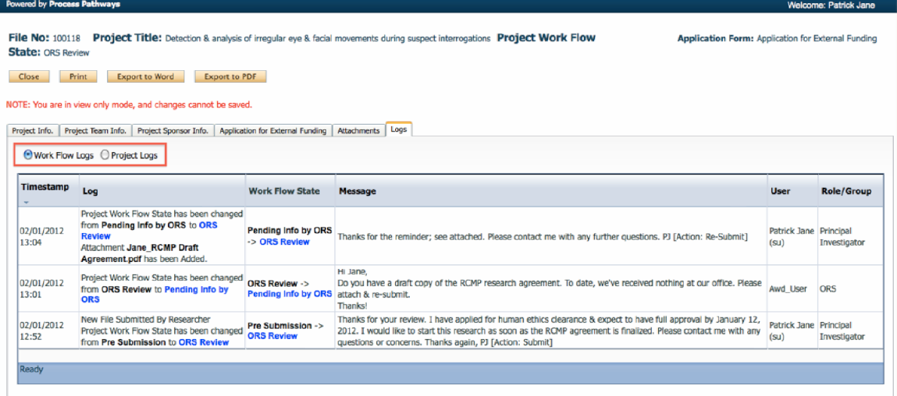

- All cleared protocols may be viewed in Applications (Submitted-Post Review).

Submit a Renewal Request, Closure Report, Change to Protocol or Adverse Events form in CuResearch

Events may be submitted to update the file for amendments or ongoing reporting (i.e., adverse events and unanticipated problems, suicidal ideation reporting, or closing the study). The relevant forms can be found on our website.

- Log into the CuResearch Researcher Portal with your MyCarletonOne credentials.

- Click Applications: Post-Review under the Principal Investigator or Project Team Member sections of the CuResearch homepage.
  - The location of the protocol will depend on your role in the study (i.e, if you are the PI it will be under “Role: Principal Investigator, if you are another team member, it will be under “Role: Project Team Member”).

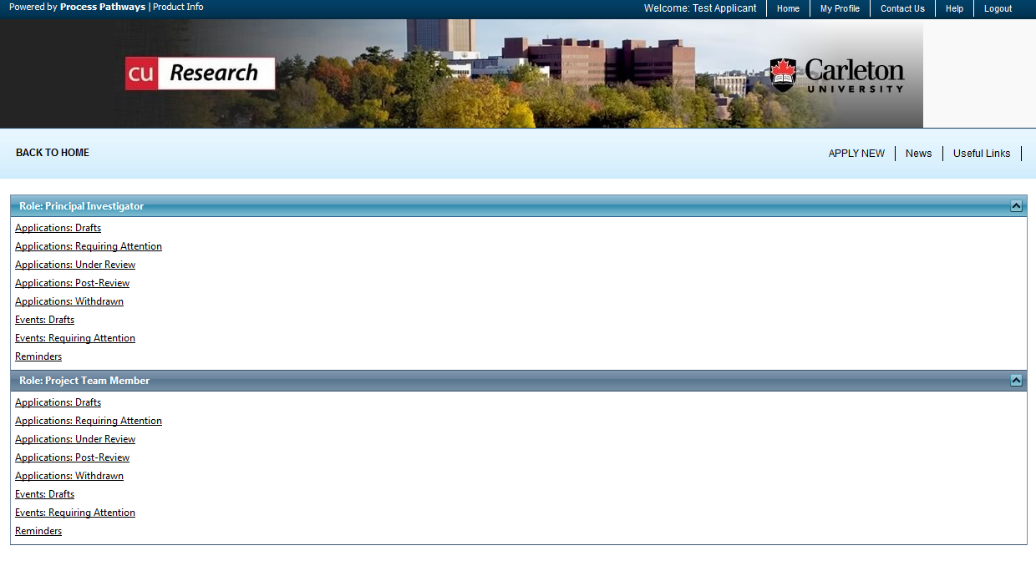

- Renewals, Closures, Changes to Protocols, and Incident Reports will be submitted as Events to the cleared protocol.
  - Click Event button to the left of the protocol title.

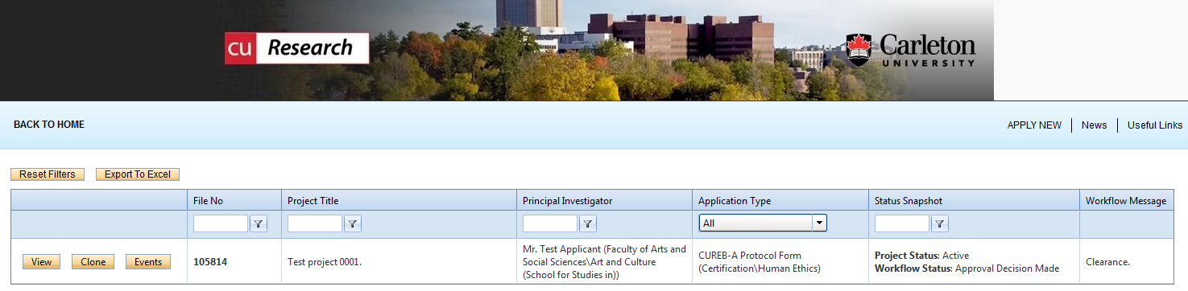

- Create a new event by selecting the CUREB Event Form under Create a New Event.
  - CUREB-A researchers should select the CUREB-A Event Form;
  - CUREB-B researchers should select the CUREB-B Event Form.

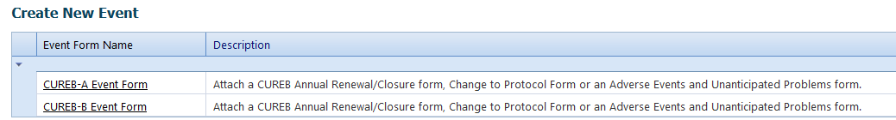

- Describe the event in the Event Info box (e.g., this is a renewal/closure/change to protocol/adverse event report).

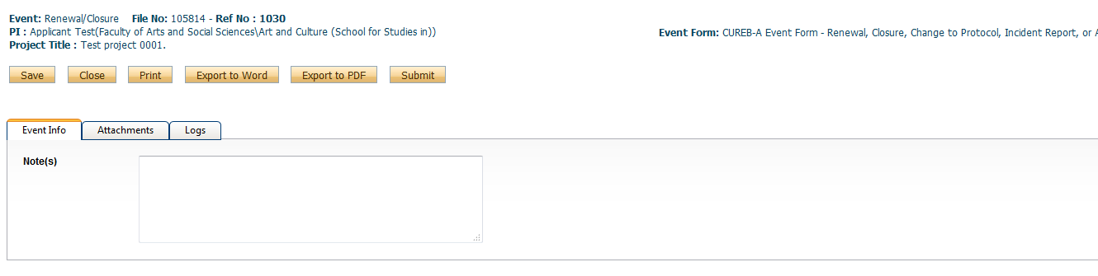

- Select the Attachments tab. Attach the relevant form from our website and any updated documents (e.g., for amendments the protocol form or appendices may need revising; to add a new project member, their TCPS2 certificate should be included). Changes to existing documents should be highlighted in yellow.
  - You may enter a description of the attachment in the Description box.
  - You may upload an attachment using the Browse button.
  - Select today’s date as the Version Date (by selecting the calendar icon next to Version Date).
  - Select the type of document in the Doc/Agreement drop down menu (e.g., Change to Protocol, Annual Status Report).

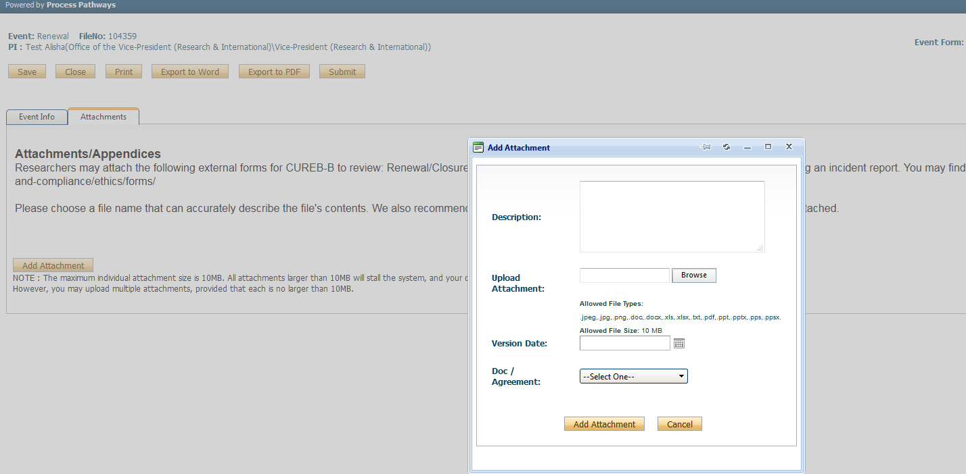

- When all documents have been attached, click the yellow “Submit” button at the top of the page.

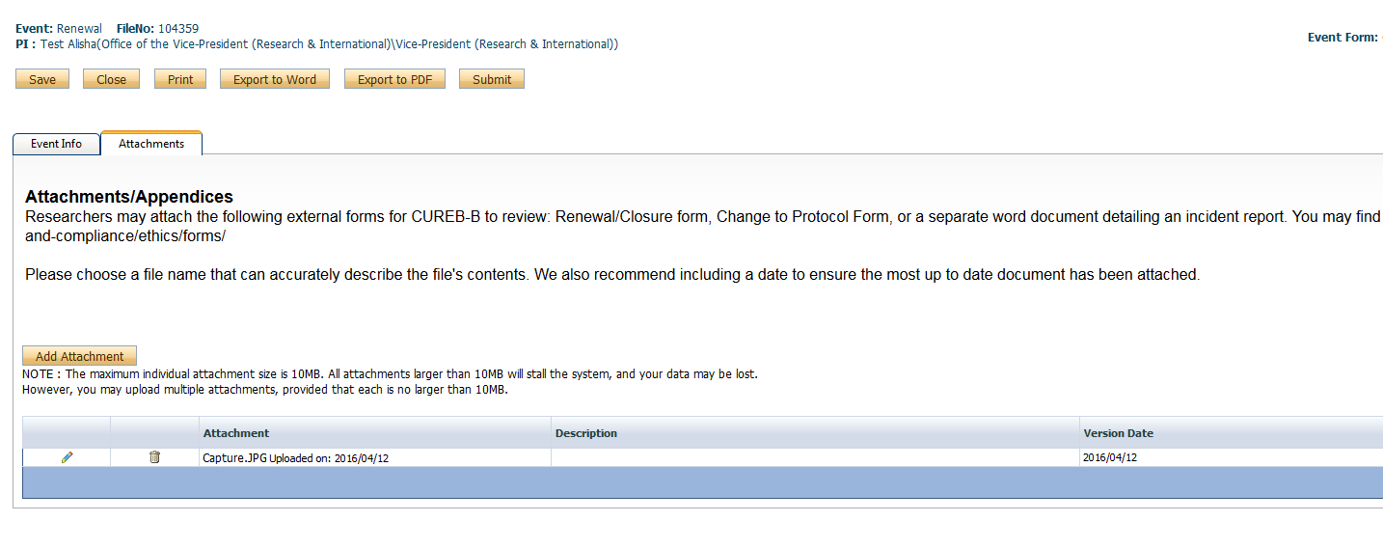
- A text-box window will pop-up after you select “Submit.” In this box, researchers can leave any pertinent notes for the Research Ethics Coordinator regarding the application. When the textbox pops up afterward, type something in the box, and then click “Submit” again – if you do not, it does not go into the system.

- Your application will now move to the Events Submitted: Under Review section of the CuResearch home page.

- An email confirmation will be sent from CuResearch when the application has been submitted.

How to Re-Submit an Event in CuResearch

- Log into the CuResearch Researcher Portal with your MyCarletonOne credentials.

- Select the Events: Requiring Attention section in the drop-down menu,
  - The location of the protocol will depend on your role in the study.

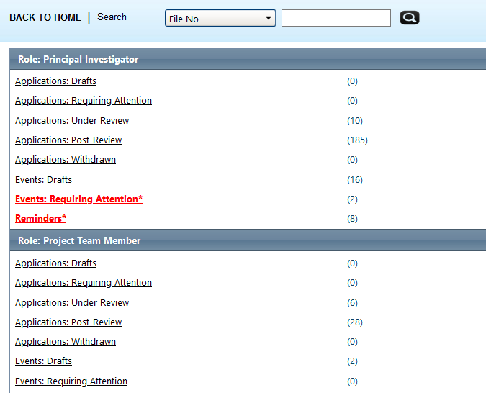

- Select the “Event” button next to the protocol title,

- Under the Events: Requiring Attention drop down menu, select “Edit”.
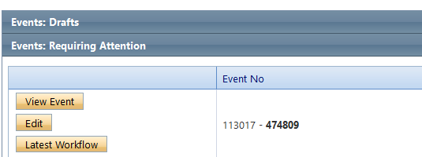

- Upload the revised form and/or attachments in the “Attachments” tab.

- Note: Do not delete the original attachments, which we keep for our records.

- If all is in order, select the yellow “Re-Submit” button.

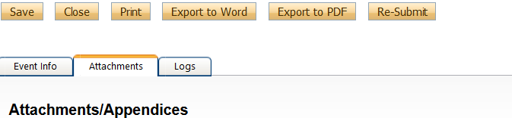

- A text-box window will pop-up after you select “Re-Submit.” In this box, researchers can leave any pertinent notes for the Research Ethics Coordinator regarding the application. When the textbox pops up afterward, type something in the box, and then click “Submit” again – if you do not, it does not go into the system.

- An email confirmation will be sent from CuResearch when the application has been re-submitted.

Frequently Asked Questions

What is the limit for attachments?

The limit for attachments is 10MB per attachment.

What does “user not validated” mean? How does a user become validated?

A user must be validated administratively; if you see this error message in CuResearch, please contact ethics@carleton.ca.

How do I remove the Errors tab?

The errors tab displays a list of all required fields and will display until all required fields are complete. All required fields will be marked with a red asterisk (*). An application cannot be submitted while the errors tab is visible.
- Click the Errors tab to review a list of all required fields not yet complete.
- The Errors tab listing will detail the required tab & field name.
- Complete all required fields (with a red asterisk) to hide the Errors tab.
- When the required fields are completed, the errors tab will disappear; you can then save and submit the application.

Will I receive notifications in CuResearch?

Please Note: Confirmation emails will be sent when the protocol has been submitted.

I think I locked my account. How do I fix it?

Files automatically lock while they are being edited by a member of the research team. The file will unlock automatically when the researcher saves and closes the file. If the file is not saved before it is closed, it will become locked. Accounts can only be unlocked administratively. Please contact ethics@carleton.ca. Saving before you close your work will prevent the account from being locked.

I am having trouble with the forms. Do I need specific software to fill out the forms before I upload them to CuResearch?

Please note that all of our forms are compatible with Microsoft Office.

